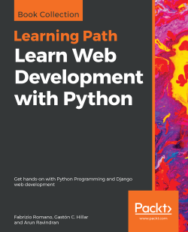

Learn Web Development with Python

By Fabrizio Romano , Gaston C. Hillar , Arun Ravindran

Publication date: December 2018

Publisher : Packt, Pages: 796, ISBN: 9781789953299

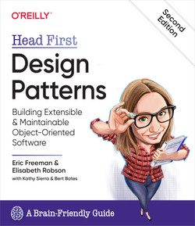

Head First Design Patterns, 2nd Edition

by Eric Freeman, Elisabeth Robson

Released December 2020, Publisher(s): O'Reilly Media, Inc.

ISBN: 9781492078005. Explore a preview version of *Head First Design Patterns, 2nd Edition* right now.

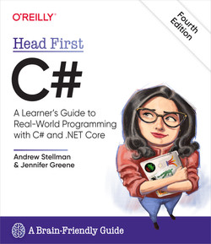

Head First C#, 4th Edition

by Andrew Stellman, Jennifer Greene

Released December 2020

Publisher(s): O'Reilly Media, Inc.

ISBN: 9781491976708

Explore a preview version of *Head First C#, 4th Edition* right now.

O’Reilly members get unlimited access to live online training experiences, plus books, videos, and digital content from 200+ publishers.

O'REILLY" , Head First C#, Edition Fourth

A Learner's Guide to Real-World Programming with C# and .NET Core

Andrew Stellman & Jennifer Greene, A Brain-Friendly Guide

**8. “An Introduction to Object-Oriented Programming in C++: with Applications in Computer Graphics” by Graham M Seed**

“An Introduction to Object-Oriented Programming in C++: with Applications in Computer Graphics” Book Review: This book provides the art of programming in C++. It covers the topics ranging from simple C++ programmes to programme features. These features include classes, templates, and namespaces. This book places an emphasis on developing a good programming technique. It also demonstrates when and how to use the advanced features of C++. This book covers the Standard Template Library (STL), a major addition to the ANSI C++ standard. It provides a full coverage of all the main topics of C++. These topics include templates and practical tools developed for object-oriented computer graphics programming.

INTRODUCTION TO ALGORITHMS, THIRD EDITION:

(THOMAS H. CORMEN

CHARLES E. LEISERSON

RONALD L. RIVEST

CLIFFORD STEIN )

Design Patterns, Elements of Reusable Object-Oriented Software

* Erich Gamma
* Richard Helm
* Ralph Johnson
* John Vlissides
* ADDISON-WESLEY PROFESSIONAL COMPUTING SERIES
* Foreword by Grady Booch

Modern C++ : Efficient and scalable Application Development- Richard Grimes. Mastering C++ 17 STL- Arthur O'Dwyer (Both by Packt Publications)

Django Design Patterns and Best Practices: Django Design PatternThe book covers some unique topics that you would not find in many other books or even online resources. Though a design patterns book, it covers a fair amount of basics about Django starting with why Django came into existence. The author discusses at length how simple and complex problems that are very common, especially when we want faster development, can be solved by making simple design changes. Knowing about various patterns can greatly reduce the coding time and enhance code performance. The author not only explains patterns but also makes sure you understand where and when to use each pattern by giving example problems and solutions. The book also covers in detail testing and security, which are the two most important aspects of any web application development.

Programming: Principles and Practice Using C++

‘Programming Principles and Practice Using C++’ opts for a fundamental approach to help its reader sharpen their programming skills. This massive book (over 1200 pages) will introduce you to the best practices for structuring your code and help you emerge as an expert programmer. For beginners, this book is an introduction to programming, as it discusses both object-oriented programming and generic programming. It acts as a robust foundation for the C++ programming language, a prominent language used worldwide for real-world software.

1. [C++ Primer (5th Edition)](http://geni.us/K6QSB)

‘C++ Primer’ by Stanley B. Lippman, Josée Lajoie, and Barbara E. Moo is considered one of the best books to learn C++ programming and is ideal for programmers of all skill levels. This nearly 1,000-page long book has everything you need to become an expert C++ programmer, right from scratch. The book, restructured for quicker and active learning, also provides ample reader examples to readers to put their skills to test. Stanley B. Lippman is a co-author of this book, a computer scientist who worked in the initial stages of C++ development. This is the best C++ books for beginners to start your journey.

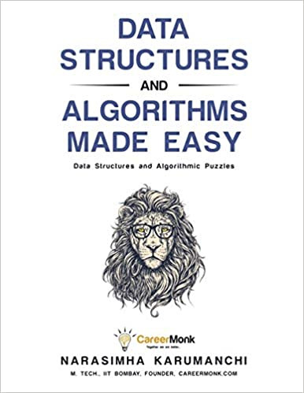

# Data Structures and Algorithms Made Easy: Data Structures and Algorithmic Puzzles 5th edition. Edition

by [Narasimha Karumanchi](https://www.amazon.com/Narasimha-Karumanchi/e/B004S7ZXQM/ref=dp_byline_cont_book_1)  (Author)

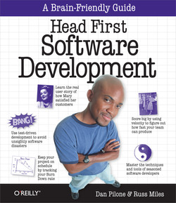

# **Head First Software Development**

by Dan Pilone, Russ Miles

Released December 2007

Publisher(s): O'Reilly Media, Inc.

ISBN: 9780596527358

Explore a preview version of Head First Software Development right now.

O’Reilly members get unlimited access to live online training experiences, plus books, videos, and digital content from 200+ publishers.

[**BUY ON AMAZON**](https://www.amazon.com/_/dp/0596527357?tag=oreilly20-20)

[**START YOUR FREE TRIAL**](https://learning.oreilly.com/p/register/)

## **Book description**

Even the best developers have seen well-intentioned software projects fail -- often because the customer kept changing requirements, and end users didn't know how to use the software you developed. Instead of surrendering to these common problems, let Head First Software Development guide you through the best practices of software development. Before you know it, those failed projects will be a thing of the past.  
  
With its unique visually rich format, this book pulls together the hard lessons learned by expert software developers over the years. You'll gain essential information about each step of the software development lifecycle -- requirements, design, coding, testing, implementing, and maintenance -- and understand why and how different development processes work.  
  
This book is for you if you are:

* Tired of your customers assuming you're psychic. You'll learn not only how to get good requirements, but how to make sure you're always building the software that customers want (even when they're not sure themselves)
* Wondering when the other 15 programmers you need to get your project done on time are going to show up. You'll learn how some very simple scheduling and prioritizing will revolutionize your success rate in developing software.
* Confused about being rational, agile, or a tester. You'll learn not only about the various development methodologies out there, but how to choose a solution that's right for your project.
* Confused because the way you ran your last project worked so well, but failed miserably this time around. You'll learn how to tackle each project individually, combine lessons you've learned on previous projects with cutting-edge development techniques, and end up with great software on every project.

Head First Software Development is here to help you learn in a way that your brain likes... and you'll have a blast along the way. Why pick up hundreds of boring books on the philosophy of this approach or the formal techniques required for that one? Stick with

Head First Software Development

, and your projects will succeed like never before. Go on, get started... you'll learn and have fun. We promise.

* **Author :** Dan Pilone
* **Publisher :** "O'Reilly Media, Inc."
* **Release Date :** 2008-12-26
* **Genre:** Computers
* **Pages :** 459
* **ISBN 10 :** 9780596527358

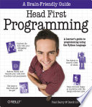

## [**Head First Programming**](https://www.itseyeris.com/book/head-first-programming)

* **Author :** David Griffiths
* **Publisher :** "O'Reilly Media, Inc."
* **Release Date :** 2009-11-16
* **Genre:** Computers
* **Pages :** 442
* **ISBN 10 :** 9781449369811

[GET BOOK](https://www.itseyeris.com/get.php?id=_zJS8gCc3pkC&t=head-first-programming&a=david-griffiths&p=o-reilly-media-inc-&h=442&d=2009-11-16&i=9781449369811&c=computers)

**Head First Programming Book Description :**

Looking for a reliable way to learn how to program on your own, without being overwhelmed by confusing concepts? Head First Programming introduces the core concepts of writing computer programs -- variables, decisions, loops, functions, and objects -- which apply regardless of the programming language. This book offers concrete examples and exercises in the dynamic and versatile Python language to demonstrate and reinforce these concepts. Learn the basic tools to start writing the programs that interest you, and get a better understanding of what software can (and cannot) do. When you're finished, you'll have the necessary foundation to learn any programming language or tackle any software project you choose. With a focus on programming concepts, this book teaches you how to: Understand the core features of all programming languages, including: variables, statements, decisions, loops, expressions, and operators Reuse code with functions Use library code to save time and effort Select the best data structure to manage complex data Write programs that talk to the Web Share your data with other programs Write programs that test themselves and help you avoid embarrassing coding errors We think your time is too valuable to waste struggling with new concepts. Using the latest research in cognitive science and learning theory to craft a multi-sensory learning experience, Head First Programming uses a visually rich format designed for the way your brain works, not a text-heavy approach that puts you to sleep.

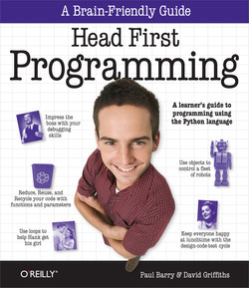

# **Head First Programming**

by David Griffiths, Paul Barry

Released November 2009

Publisher(s): O'Reilly Media, Inc.

ISBN: 9780596802370

Explore a preview version of Head First Programming right now.

O’Reilly members get unlimited access to live online training experiences, plus books, videos, and digital content from 200+ publishers.

[**BUY ON AMAZON**](https://www.amazon.com/_/dp/0596802374?tag=oreilly20-20)

[**START YOUR FREE TRIAL**](https://learning.oreilly.com/p/register/)

## **Book description**

Looking for a reliable way to learn how to program on your own, without being overwhelmed by confusing concepts? Head First Programming introduces the core concepts of writing computer programs -- variables, decisions, loops, functions, and objects -- which apply regardless of the programming language. This book offers concrete examples and exercises in the dynamic and versatile Python language to demonstrate and reinforce these concepts.  
  
Learn the basic tools to start writing the programs that interest you, and get a better understanding of what software can (and cannot) do. When you're finished, you'll have the necessary foundation to learn any programming language or tackle any software project you choose.  
  
With a focus on programming concepts, this book teaches you how to:

* Understand the core features of all programming languages, including: variables, statements, decisions, loops, expressions, and operators
* Reuse code with functions
* Use library code to save time and effort
* Select the best data structure to manage complex data
* Write programs that talk to the Web
* Share your data with other programs
* Write programs that test themselves and help you avoid embarrassing coding errors

We think your time is too valuable to waste struggling with new concepts. Using the latest research in cognitive science and learning theory to craft a multi-sensory learning experience, Head First Programming uses a visually rich format designed for the way your brain works, not a text-heavy approach that puts you to sleep.

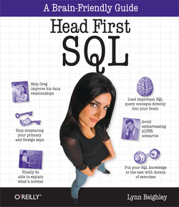

Head First SQL

by Lynn Beighley

Released August 2007

Publisher(s): O'Reilly Media, Inc.

ISBN: 9780596526849

Explore a preview version of *Head First SQL* right now.

O’Reilly members get unlimited access to live online training experiences, plus books, videos, and digital content from 200+ publishers.

[**BUY ON AMAZON**](https://www.amazon.com/_/dp/0596526849?tag=oreilly20-20)

[**START YOUR FREE TRIAL**](https://learning.oreilly.com/p/register/)

Book description

Is your data dragging you down? Are your tables all tangled up? Well we've got the tools to teach you just how to wrangle your databases into submission. Using the latest research in neurobiology, cognitive science, and learning theory to craft a multi-sensory SQL learning experience, *Head First SQL* has a visually rich format designed for the way your brain works, not a text-heavy approach that puts you to sleep.  
  
Maybe you've written some simple SQL queries to interact with databases. But now you want more, you want to really dig into those databases and work with your data. *Head First SQL* will show you the fundamentals of SQL and how to really take advantage of it. We'll take you on a journey through the language, from basic INSERT statements and SELECT queries to hardcore database manipulation with indices, joins, and transactions. We all know "Data is Power" - but we'll show you how to have "Power over your Data". Expect to have fun, expect to learn, and expect to be querying, normalizing, and joining your data like a pro by the time you're finished reading!

* **Author :** Lynn Beighley
* **Publisher :** O'Reilly Media
* **Release Date :** 2007-08-28
* **Genre:** Computers
* **Pages :** 607
* **ISBN 10 :** 9780596800857

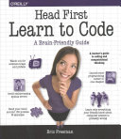

## [**Head First Learn to Code**](https://www.itseyeris.com/book/head-first-learn-to-code)

* **Author :** Eric Freeman
* **Publisher :** Unknown
* **Release Date :** 2018-01-12
* **Genre:** Computers
* **Pages :** 640
* **ISBN 10 :** 1491958863

[GET BOOK](https://www.itseyeris.com/get.php?id=FO4htAEACAAJ&t=head-first-learn-to-code&a=eric-freeman&p=unknown&h=640&d=2018-01-12&i=1491958863&c=computers)

**Head First Learn to Code Book Description :**

What will you learn from this book? It's no secret the world around you is becoming more connected, more configurable, more programmable, more computational. You can remain a passive participant, or you can learn to code. With Head First Learn to Code you'll learn how to think computationally and how to write code to make your computer, mobile device, or anything with a CPU do things for you. Using the Python programming language, you'll learn step by step the core concepts of programming as well as many fundamental topics from computer science, such as data structures, storage, abstraction, recursion, and modularity. Why does this book look so different? Based on the latest research in cognitive science and learning theory, Head First Learn to Code uses a visually rich format to engage your mind, rather than a text-heavy approach that puts you to sleep. Why waste your time struggling with new concepts? This multi-sensory learning experience is designed for the way your brain really works.

# **Head First Learn to Code**

by Eric Freeman

Released January 2018

Publisher(s): O'Reilly Media, Inc.

ISBN: 9781491958865

Explore a preview version of Head First Learn to Code right now.

O’Reilly members get unlimited access to live online training experiences, plus books, videos, and digital content from 200+ publishers.

[**BUY ON AMAZON**](https://www.amazon.com/_/dp/1491958863?tag=oreilly20-20)

[**START YOUR FREE TRIAL**](https://learning.oreilly.com/p/register/)

## **Book description**

**What will you learn from this book?**

It’s no secret the world around you is becoming more connected, more configurable, more programmable, more computational. You can remain a passive participant, or you can learn to code. With *Head First Learn to Code* you’ll learn how to *think computationally* and how to *write code* to make your computer, mobile device, or anything with a CPU *do things for you.* Using the Python programming language, you’ll learn step by step the core concepts of programming as well as many fundamental topics from computer science, such as data structures, storage, abstraction, recursion, and modularity.

**Why does this book look so different?**

Based on the latest research in cognitive science and learning theory, *Head First Learn to Code* uses a visually rich format to engage your mind, rather than a text-heavy approach that puts you to sleep. Why waste your time struggling with new concepts? This multi-sensory learning experience is designed for the way your brain really works.

Show and hide more

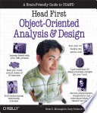

Score: 4

From 24 Ratings

[Head First Object Oriented Analysis and Design](https://www.itseyeris.com/book/head-first-object-oriented-analysis-and-design)

* **Author :** Brett McLaughlin
* **Publisher :** "O'Reilly Media, Inc."
* **Release Date :** 2006-11-27
* **Genre:** Computers
* **Pages :** 600
* **ISBN 10 :** 9780596008673

[GET BOOK](https://www.itseyeris.com/get.php?id=-QpmamSKl_EC&t=head-first-object-oriented-analysis-and-design&a=brett-mclaughlin&p=o-reilly-media-inc-&h=600&d=2006-11-27&i=9780596008673&c=computers)

**Head First Object Oriented Analysis and Design Book Description :**

Provides information on analyzing, designing, and writing object-oriented software.

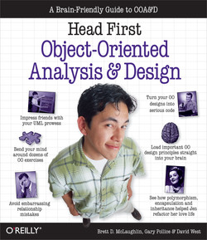

Head First Object-Oriented Analysis and Design

by Brett McLaughlin, Gary Pollice, David West

Released November 2006

Publisher(s): O'Reilly Media, Inc.

ISBN: 9780596008673

Explore a preview version of *Head First Object-Oriented Analysis and Design* right now.

O’Reilly members get unlimited access to live online training experiences, plus books, videos, and digital content from 200+ publishers.

[**BUY ON AMAZON**](https://www.amazon.com/_/dp/0596008678?tag=oreilly20-20)

[**START YOUR FREE TRIAL**](https://learning.oreilly.com/p/register/)

Book description

"Head First Object Oriented Analysis and Design is a refreshing look at subject of OOAD. What sets this book apart is its focus on learning. The authors have made the content of OOAD accessible, usable for the practitioner."  
  
Ivar Jacobson, Ivar Jacobson Consulting

"I just finished reading HF OOA&D and I loved it! The thing I liked most about this book was its focus on why we do OOA&D-to write great software!"  
  
Kyle Brown, Distinguished Engineer, IBM

Show and hide more

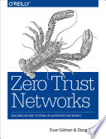

## [**Zero Trust Networks**](https://www.itseyeris.com/book/zero-trust-networks)

* **Author :** Evan Gilman
* **Publisher :** "O'Reilly Media, Inc."
* **Release Date :** 2017-06-19
* **Genre:** Computers
* **Pages :** 240
* **ISBN 10 :** 9781491962169

[GET BOOK](https://www.itseyeris.com/get.php?id=eawoDwAAQBAJ&t=zero-trust-networks&a=evan-gilman&p=o-reilly-media-inc-&h=240&d=2017-06-19&i=9781491962169&c=computers)

**Zero Trust Networks Book Description :**

The perimeter defenses guarding your network perhaps are not as secure as you think. Hosts behind the firewall have no defenses of their own, so when a host in the "trusted" zone is breached, access to your data center is not far behind. That’s an all-too-familiar scenario today. With this practical book, you’ll learn the principles behind zero trust architecture, along with details necessary to implement it. The Zero Trust Model treats all hosts as if they’re internet-facing, and considers the entire network to be compromised and hostile. By taking this approach, you’ll focus on building strong authentication, authorization, and encryption throughout, while providing compartmentalized access and better operational agility. Understand how perimeter-based defenses have evolved to become the broken model we use today Explore two case studies of zero trust in production networks on the client side (Google) and on the server side (PagerDuty) Get example configuration for open source tools that you can use to build a zero trust network Learn how to migrate from a perimeter-based network to a zero trust network in production

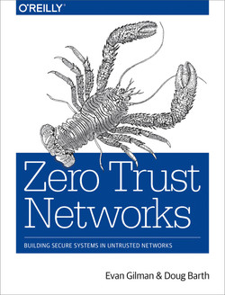

Zero Trust Networks

by Evan Gilman, Doug Barth

Released July 2017

Publisher(s): O'Reilly Media, Inc.

ISBN: 9781491962190

Explore a preview version of *Zero Trust Networks* right now.

O’Reilly members get unlimited access to live online training experiences, plus books, videos, and digital content from 200+ publishers.

[**BUY ON AMAZON**](https://www.amazon.com/_/dp/1491962194?tag=oreilly20-20)

[**START YOUR FREE TRIAL**](https://learning.oreilly.com/p/register/)

Book description

The perimeter defenses guarding your network perhaps are not as secure as you think. Hosts behind the firewall have no defenses of their own, so when a host in the "trusted" zone is breached, access to your data center is not far behind. That’s an all-too-familiar scenario today. With this practical book, you’ll learn the principles behind zero trust architecture, along with details necessary to implement it.

The Zero Trust Model treats all hosts as if they’re internet-facing, and considers the entire network to be compromised and hostile. By taking this approach, you’ll focus on building strong authentication, authorization, and encryption throughout, while providing compartmentalized access and better operational agility.

* Understand how perimeter-based defenses have evolved to become the broken model we use today
* Explore two case studies of zero trust in production networks on the client side (Google) and on the server side (PagerDuty)
* Get example configuration for open source tools that you can use to build a zero trust network
* Learn how to migrate from a perimeter-based network to a zero trust network in production

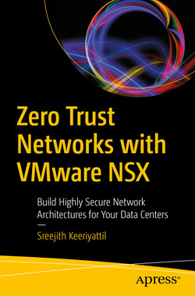

# **Zero Trust Networks with VMware NSX: Build Highly Secure Network Architectures for Your Data Centers**

by Sreejith Keeriyattil

Released November 2019

Publisher(s): Apress

ISBN: 9781484254318

Explore a preview version of Zero Trust Networks with VMware NSX: Build Highly Secure Network Architectures for Your Data Centers right now.

O’Reilly members get unlimited access to live online training experiences, plus books, videos, and digital content from 200+ publishers.

[**START YOUR FREE TRIAL**](https://learning.oreilly.com/p/register/)

## **Book description**

Secure your VMware infrastructure against distrusted networks using VMware NSX. This book shows you why current security firewall architecture cannot protect against new threats to your network and how to build a secure architecture for your data center.

Author Sreerjith Keeriyattil teaches you how micro-segmentation can be used to protect east-west traffic. Insight is provided into working with Service Composer and using NSX REST API to automate firewalls. You will analyze flow and security threats to monitor firewalls using VMware Log and see how Packet Flow works with VMware NSX micro-segmentation.

The information presented in ***Zero Trust Networks with VMware NSX*** allows you to study numerous attack scenarios and strategies to stop these attacks, and know how VMware Air Watch can further improve your architecture.

**What You Will Learn**

* Know how micro-segmentation works and its benefits
* Implement VMware-distributed firewalls
* Automate security policies
* Integrate IPS/IDS with VMware NSX
* Analyze your firewall's configurations, rules, and policies

**Who This Book Is For**

Experienced VMware administrators and security administrators who have an understanding of data center architecture and operations

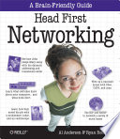

[Head First Networking](https://www.itseyeris.com/book/head-first-networking)

* **Author :** Al Anderson
* **Publisher :** "O'Reilly Media, Inc."
* **Release Date :** 2009-05-27
* **Genre:** Computers
* **Pages :** 538
* **ISBN 10 :** 9781449368142

[GET BOOK](https://www.itseyeris.com/get.php?id=uXUrAQAAQBAJ&t=head-first-networking&a=al-anderson&p=o-reilly-media-inc-&h=538&d=2009-05-27&i=9781449368142&c=computers)

**Head First Networking Book Description :**

Frustrated with networking books so chock-full of acronyms that your brain goes into sleep mode? Head First Networking's unique, visually rich format provides a task-based approach to computer networking that makes it easy to get your brain engaged. You'll learn the concepts by tying them to on-the-job tasks, blending practice and theory in a way that only Head First can. With this book, you'll learn skills through a variety of genuine scenarios, from fixing a malfunctioning office network to planning a network for a high-technology haunted house. You'll learn exactly what you need to know, rather than a laundry list of acronyms and diagrams. This book will help you: Master the functionality, protocols, and packets that make up real-world networking Learn networking concepts through examples in the field Tackle tasks such as planning and diagramming networks, running cables, and configuring network devices such as routers and switches Monitor networks for performance and problems, and learn troubleshooting techniques Practice what you've learned with nearly one hundred exercises, questions, sample problems, and projects Head First's popular format is proven to stimulate learning and retention by engaging you with images, puzzles, stories, and more. Whether you're a network professional with a CCNA/CCNP or a student taking your first college networking course, Head First Networking will help you become a network guru.

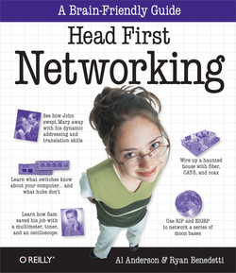

Head First Networking

by Al Anderson, Ryan Benedetti

Released May 2009

Publisher(s): O'Reilly Media, Inc.

ISBN: 9780596521554

Explore a preview version of *Head First Networking* right now.

O’Reilly members get unlimited access to live online training experiences, plus books, videos, and digital content from 200+ publishers.

[**BUY ON AMAZON**](https://www.amazon.com/_/dp/0596521553?tag=oreilly20-20)

[**START YOUR FREE TRIAL**](https://learning.oreilly.com/p/register/)

Book description

Frustrated with networking books so chock-full of acronyms thatyour brain goes into sleep mode? *Head First Networking's*unique, visually rich format provides a task-based approach tocomputer networking that makes it easy to get your brain engaged.You'll learn the concepts by tying them to on-the-job tasks,blending practice and theory in a way that only Head Firstcan.With this book, you'll learn skills through a variety of genuinescenarios, from fixing a malfunctioning office network to planninga network for a high-technology haunted house. You'll learn exactlywhat you need to know, rather than a laundry list of acronyms anddiagrams. This book will help you:

• Master the functionality, protocols, and packets that make upreal-world networking

• Learn networking concepts through examples in the field

• Tackle tasks such as planning and diagramming networks, runningcables, and configuring network devices such as routers andswitches

• Monitor networks for performance and problems, and learntroubleshooting techniques

• Practice what you've learned with nearly one hundred exercises,questions, sample problems, and projects

Head First's popular format is proven to stimulate learning andretention by engaging you with images, puzzles, stories, and more.Whether you're a network professional with a CCNA/CCNP or a studenttaking your first college networking course, *Head FirstNetworking* will help you become a network guru.

Show and hide more

